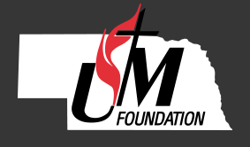

Donation Instructions for Securities and Mutual Funds

The NEBRASKA UNITED METHODIST FOUNDATION maintains an account with Union Bank & Trust Co. in Lincoln, NE for processing gifts of publicly traded Securities and Mutual Funds. Your gift to the Foundation can be used to benefit any area or specific program within the Foundation, the Nebraska Annual Conference, or a local church.

Completing the information below ensures that we distribute the proceeds according to your wishes and send you an acknowledgement which complies with IRS regulations. Once received we will provide further direction on delivery of your gift to the Foundation.

Name of Donor (s): _____________________________________________________________

- Address: _______________________________________________________________

- Phone: ____________________________________

Name of Security Donated: _____________________________________________________

- Quantity of Shares Donated: ______________________________________________

Donor’s Broker/Agent: ______________________________________________

- Broker/Agent Phone: _________________________________________

- Broker/Agent E-mail: _________________________________________

Date of Gift: ___________________________

Specify directions for use of gift. (Gifts can be restricted to a specific community and/or program.):

Mail, fax or e-mail this page to:

The Nebraska United Methodist Foundation (fax) 402-323-8840
100 W Fletcher Avenue Ste 100 (e-mail) mlogsdon@numf.org
Lincoln, NE 68521

If you have questions, please contact us at 877-495-5545

