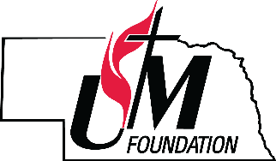 Nebraska United Methodist Foundation
2nd Round COVID-19 Emergency Grant Policy & Application

The Nebraska United Methodist Foundation (“Foundation”) strives to serve as a catalyst to strengthen and preserve the ministries of our churches and individuals through education, planning, resourcing, and financial management.

The Foundation is offering a 2nd round of Covid-19 Emergency Grants. Total to be distributed from a donor-established endowment fund through our Gifts From The Heart Endowments will be $55,000, to commemorate the Foundation’s 55th Anniversary. These grants are available to Nebraska United Methodist churches, camps and ministries to assist with greatest needs.

Only one application per church/organization will be accepted. Applications are due by January 29, 2021. Applications not postmarked or received electronically by this date will not be considered. Grant checks will be mailed by March 1, 2021.

Grant applications will be reviewed by the Foundation’s staff. The Foundation reserves the right to reject in whole or in part any grant application that it deems to be incomplete or not in accordance with the mission and policies set forth by the Foundation. By submitting this application the church/organization agrees to provide the Foundation updates on grant project/usage and allows the Foundation to use this information in their publications.

For questions, please contact Rev. Dr. Matt Fowler at 402-323-8842 or at mfowler@numf.org.
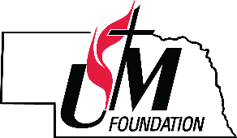Nebraska Area United Methodist Foundation
COVID-19 Emergency Grant Application

PLEASE PRINT OR TYPE

Name of Church/Organization:

Name of Person Applying: Phone:

Mailing Address:

City: State: Zip: Email:

District in the State of Nebraska:___________________________________________________

How will this grant be used?

________________________________________________________________________________

________________________________________________________________________________

________________________________________________________________________________

________________________________________________________________________________

Completed forms need to be submitted to:
Rev. Dr. Matt Fowler, Director of Stewardship, mfowler@numf.org.
If you do not receive a confirmation receipt from Rev. Fowler within 1-2 business days, please contact the Foundation.

Or applications are also accepted by mail:
Nebraska United Methodist Foundation
100 W Fletcher Ave, Ste 100
Lincoln, NE 68521
----------------------------------------------------------------------------------------------------

Are you aware that the Foundation provides the following services, all free of charge? Yes___ No ___
- The creation and development of endowment funds
- Presentations of Foundation investment services to committees and congregations
- Gift & estate planning seminars and fund development workshops
- Planned gift visits with individuals to establish long-term support for the church
- Stewardship sermons
- Assistance in the development of a planned giving ministry within your church

To learn more about any of these services or to invite the Foundation into your church via Zoom or
in-person, please contact us at 402-323-8844.

