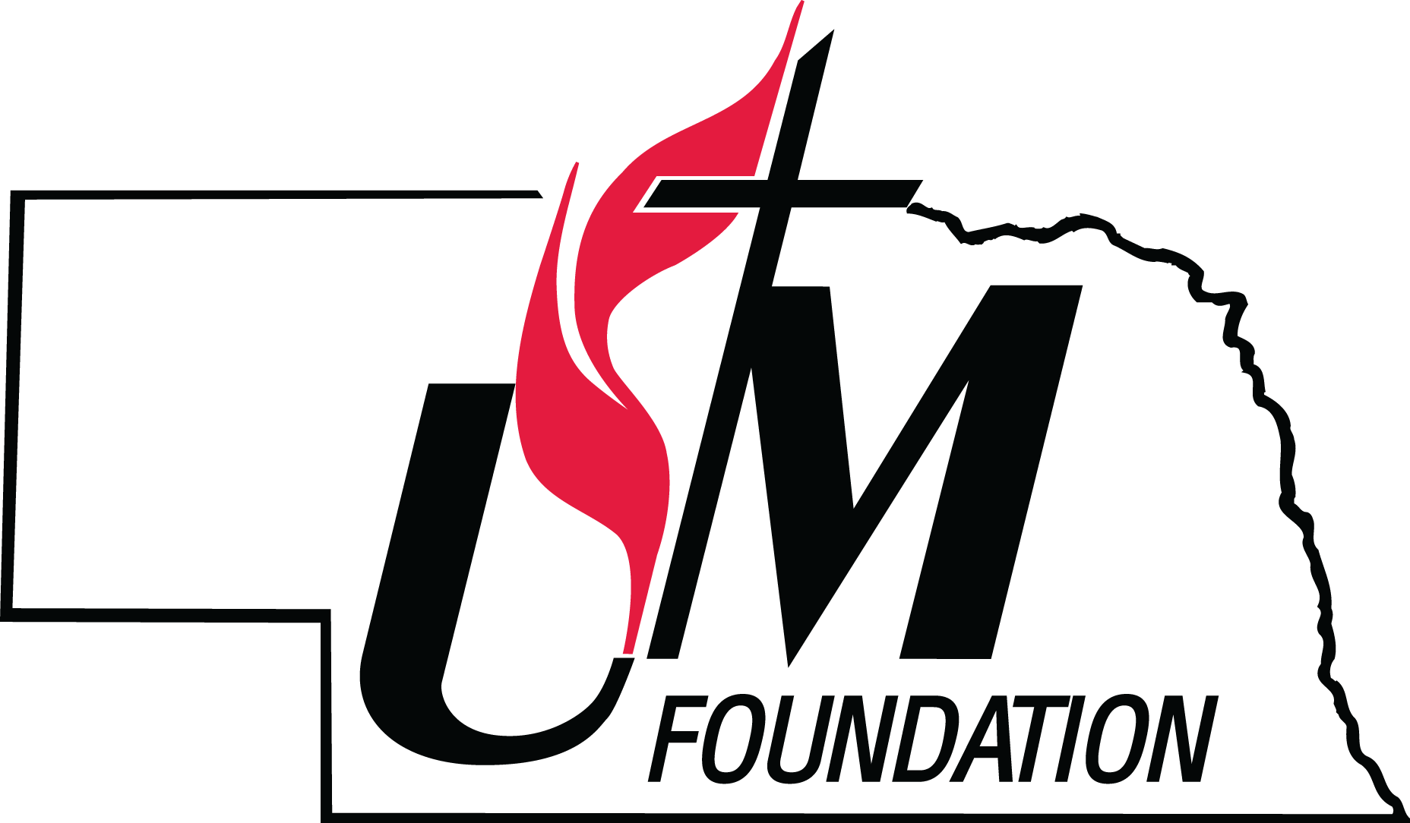
NEBRASKA UNITED METHODIST FOUNDATION
NEW START/NEW FAITH COMMUNITY GRANT
ANNUAL PROCESS

It is the mission of the Nebraska United Methodist Foundation (“Foundation”) to be a catalyst that strengthens our Nebraska ministries and supports and develops innovative ministries meeting the needs of a diverse and rapidly changing society.

Grant applicants should be aware that priority will be given to the following:

- A New Start deemed to be of an outreach and beneficial nature to the larger community.

- A New Start that is in collaboration with other United Methodist entities.

- A New Start that has identified other sources of revenue.

- A New Start that is an integral part of a long-range plan for growth and outreach.

Grants will be awarded on an annual basis. Grant applications must be received no later than APRIL 1st to be considered for a grant to be awarded upon commencement of the program during the following calendar year.

Grants approved by the Foundation’s Stewardship Committee are subject to the approval of the Board of Directors of the Foundation. The Foundation reserves the right to reject in whole or in part any grant application that it deems to be incomplete or not in accordance with the mission and policies set forth by the Foundation. The decision of the Board of Directors of the Foundation regarding all awards shall be final.

Grants may be renewable up to three consecutive years contingent upon the availability of funding sources and the quality and scope of the project. It is not guaranteed that grants will be awarded the full amount of the request. Grants will be conditional upon requirements being met and documented to the Foundation’s satisfaction. All grants awarded shall require no less than annual reporting to the Foundation as to the progress of the project, how the funds were used within the progress and the financial activity resulting from the grant in the event that the grant is awarded and will be applied for again the following year. If a new application with a progress and financial activity report is not received, the ministry will not be considered for future grants.

For additional information, please contact:
Kristine Roberts, Executive Director
Nebraska United Methodist Foundation
100 W. Fletcher Ave, Ste. 100
Lincoln, NE 68521
402-323-8842
kroberts@numf.org

